**Hilman Abu Dzarrin**

**D4 LJ PJJ**

**Tugas 3 Representasi Pengetahuan Semantic Network**

**Soal**

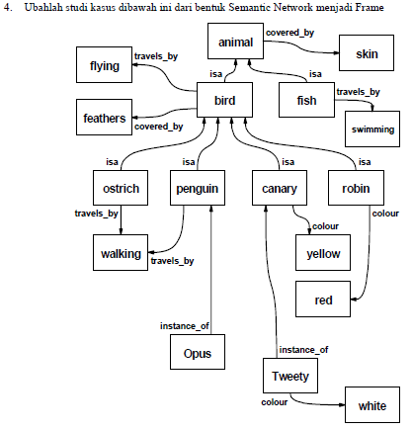

**Jawaban**

1. Frame

white

is a

ako

tweety

is a

yellow

is a

red

ako

a kind of

a kind of

Opus

walking

is a

is a

robin

canary

is a

penguin

is a

ostrich

is a

feathers

bird

flying

a kind of

swimming

is a

fish

is a

skin

animal

head

2. Prolog

isa(fish,animal).

isa(bird,animal).

isa(robin,bird).

isa(canary,bird).

isa(penguin,bird).

isa(ostrich,bird).

covered_by(animal,skin).

covered_by(bird,feathers).

travels_by(fish,swimming).

travels_by(bird,flying).

travels_by(ostrich,walking).

travels_by(penguin,walking).

colour(robin,red).

colour(canary,yellow).

colour(tweety,white).

instance(opus,penguin).

instance(tweety,canary).

subclass(Class1,Class2) :- isa(Class1,Class2).

subclass(Class1,Class2) :- isa(Class1,Class3), subclass (Class3,Class2).

aninstance(Objek,Class) :- instance(Objek,Class).

aninstance(Objek,Class) :- instance(Objek,Class1), subclass (Class1,Class).

attribute(Objek,X) :- aninstance(Objek,Class),covered_by (Class,X).

attribute(Objek,X) :- aninstance(Objek,Class),travels_by (Class,X).

attribute(Objek,X) :- aninstance(Objek,Class),colour(Class,X).

3. Screenshoot

- Subclass

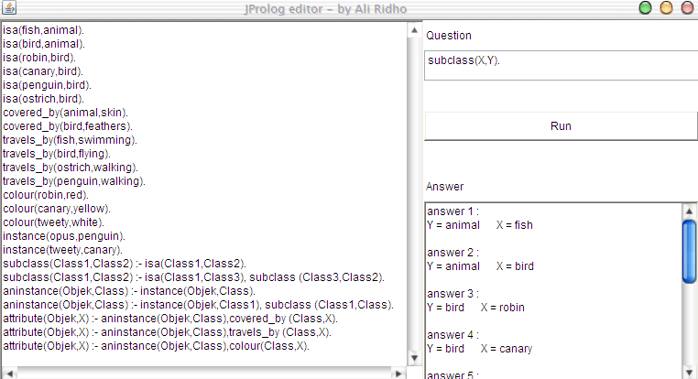

-Subclass bird

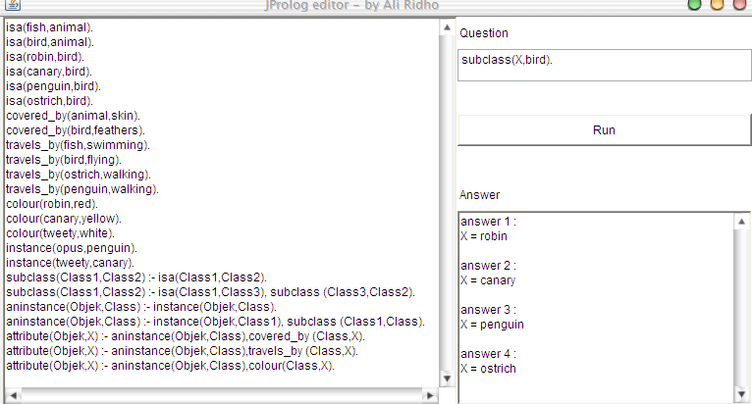

-Subclass fish

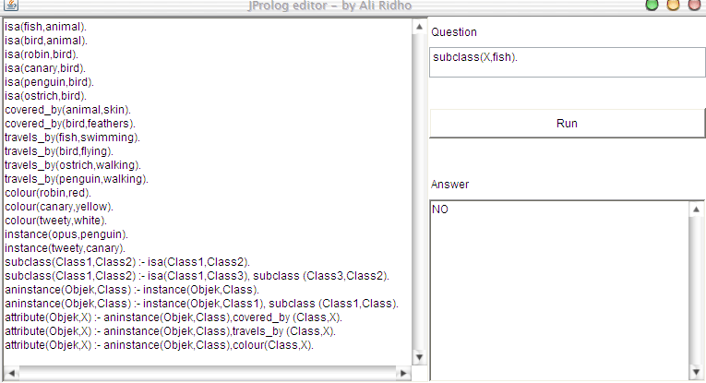

-Instance

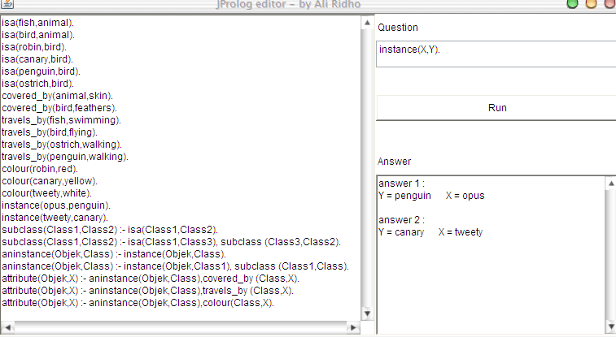

-Attribute

